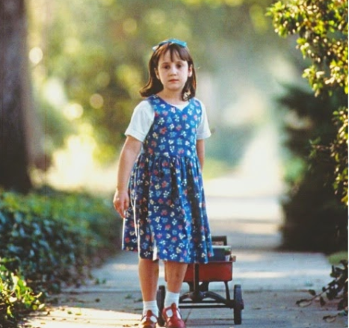
Parent-Teacher Conference Analysis
Student: Matilda Wormwood.

Recommendations
Microsystem: YES | Matilda wormwood is not close with her family. She is neglected by family for being different. She is constantly belittled and lectured by her parents. According to Bronfenbrenner, the microsystem directly impacts the child. Matilda has a positive relationship with her teacher. However, she disagrees with school headmistress but she is supported socially, academically, and personally by her teacher.
Mesosystem: NO | Matilda’s parents and the teacher interact in a positive and effective manner. The presentation case study has no clear records of disagreement and if so, there could be suggestions to transfer her to a better school. According to Bronfenbrenner, the mesosystem has to do with the interaction of a child’s microsystems. For Matilda, that would be the interactions between her parents and teacher and have an impact in her psychological growth.
Exosystem: YES | Matilda’s environment thus far has not been stable. She feels not been understood by her environments. She experiences trauma from school and home. According to Bronfenbrenner, the Exosystem refers to decisions that impact the individual without their input. Decisions on the choice of the school and the environment were barely not hers either.
Macrosystem: YES | Matilda appears to have cultural conflicts within her current school setting. According to Bronfenbrenner, the macrosystem is when a child’s culture conflicts or influences the child directly. Matilda has rebelled against family values and moral on knowledge that father’s business is illegal. This has limited her ability to learn her culture and also inherit it from her parents.

